Boundary Gap

Definition
# Source: AI Source: Provided by: [Data Path: Persons Table -> ID Column: 1, Name_En Column: Motasem Essam] -> From: [ChatGPT] on [7/25/2026]
A Boundary Gap is the empty space separating the boundaries of two geometric objects or regions.
It describes the separation between the nearest points of their boundaries, usually measured by the shortest distance between those boundaries.
For two boundaries $∂A$and $∂B$:
$$\boxed{g=d\left(∂ , A∂B\right)}$$
where $g$ is the boundary gap.
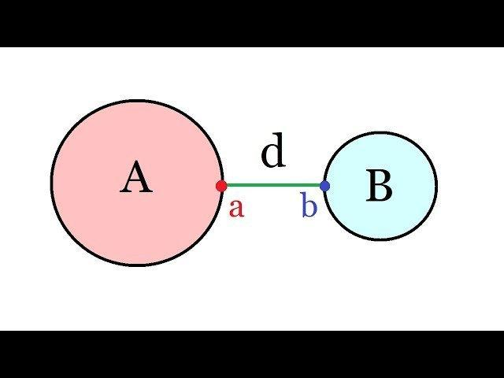
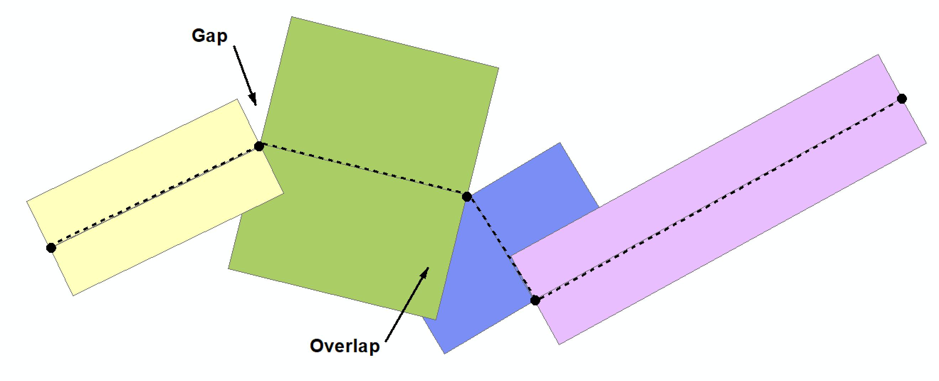
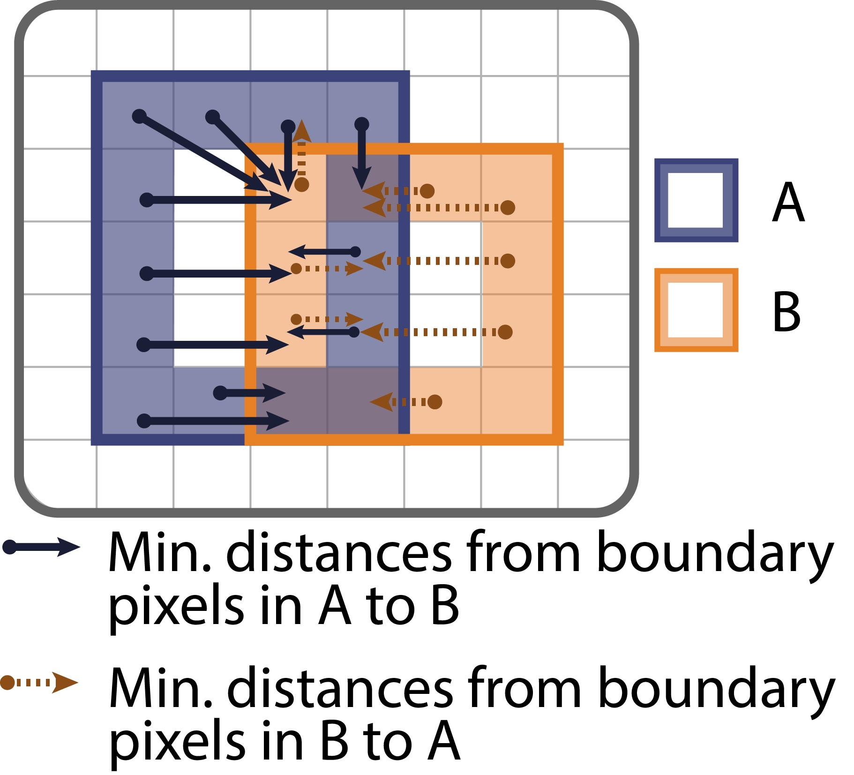

Purpose
# Source: AI Source: Provided by: [Data Path: Persons Table -> ID Column: 1, Name_En Column: Motasem Essam] -> From: [ChatGPT] on [7/25/2026]
A Boundary Gap is used to:
- Describe space between two geometric boundaries.
- Measure separation between regions.
- Determine whether two boundaries are separated or touching.
- Describe clearance between shapes.
- Analyze spacing between geometric objects.

Fundamental Concept
# Source: AI Source: Provided by: [Data Path: Persons Table -> ID Column: 1, Name_En Column: Motasem Essam] -> From: [ChatGPT] on [7/25/2026]
Consider two separate regions:
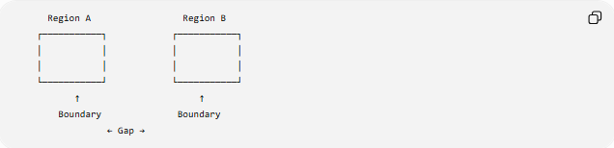
Region A Region B
┌───────────┐ ┌───────────┐
│ │ │ │
│ │ │ │
└───────────┘ └───────────┘
↑ ↑
Boundary Boundary
← Gap →
The gap is the empty space between the nearest parts of the two boundaries.
If $P$and $Q$are the closest boundary points:
$$P∈∂A, Q∈∂B$$
then:
$$\boxed{g=PQ}$$

Mathematical Representation
# Source: AI Source: Provided by: [Data Path: Persons Table -> ID Column: 1, Name_En Column: Motasem Essam] -> From: [ChatGPT] on [7/25/2026]
The boundary of a region $A$is commonly written as:
$$\boxed{∂A}$$
For two regions $A$and $B$, their boundary gap can be represented as:
$$\boxed{g=inf⁡\left\{d , \left(P , Q\right):P∈∂A Q∈∂B\right\}}$$
For many simple closed shapes, this is simply the shortest distance between their boundaries.

Positive Boundary Gap
# Source: AI Source: Provided by: [Data Path: Persons Table -> ID Column: 1, Name_En Column: Motasem Essam] -> From: [ChatGPT] on [7/25/2026]
When the boundaries are separated:
$$\boxed{g>0}$$
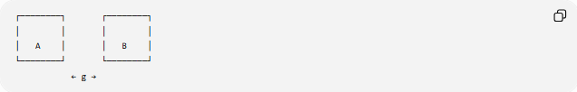
┌────────┐ ┌────────┐
│ │ │ │
│ A │ │ B │
└────────┘ └────────┘
← g →
The regions do not touch.

Zero Boundary Gap
# Source: AI Source: Provided by: [Data Path: Persons Table -> ID Column: 1, Name_En Column: Motasem Essam] -> From: [ChatGPT] on [7/25/2026]
When the boundaries touch:
$$\boxed{g=0}$$
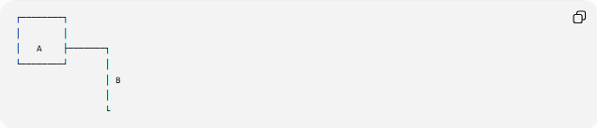
┌────────┐
│ │
│ A ├───────┐
└────────┘ │
│ B
│
└
There is no positive empty space between the touching boundaries.

Boundary Gap vs. Region Gap
# Source: AI Source: Provided by: [Data Path: Persons Table -> ID Column: 1, Name_En Column: Motasem Essam] -> From: [ChatGPT] on [7/25/2026]
These are related but different concepts.
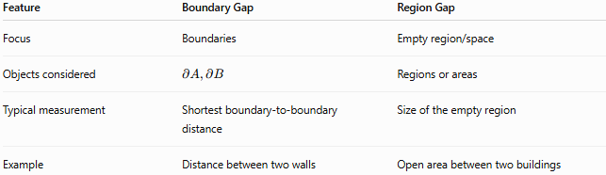
Feature | Boundary Gap | Region Gap
Focus | Boundaries | Empty region/space
Objects considered | $$∂A,∂B$$ | Regions or areas
Typical measurement | Shortest boundary-to-boundary distance | Size of the empty region
Example | Distance between two walls | Open area between two buildings
A Boundary Gap can therefore be used to measure the separation of boundaries, while a Region Gap emphasizes the empty region itself.

Boundary Gap vs. Linear Gap
# Source: AI Source: Provided by: [Data Path: Persons Table -> ID Column: 1, Name_En Column: Motasem Essam] -> From: [ChatGPT] on [7/25/2026]
A Linear Gap is associated with separation along a line.
A Boundary Gap is associated with separation between boundaries, which may be curved or irregular.
For example:
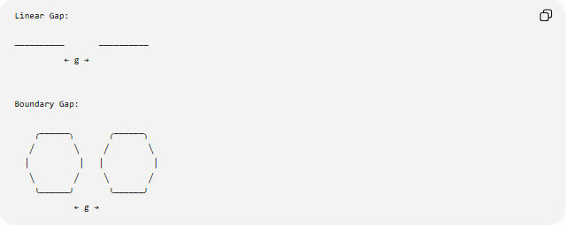
Linear Gap:

────────── ──────────
← g →

Boundary Gap:

╭──────╮ ╭──────╮
╱ ╲ ╱ ╲
│ │ │ │
╲ ╱ ╲ ╱
╰──────╯ ╰──────╯
← g →
The boundaries do not have to be straight.

Examples

Example 1: Two Parallel Boundaries
# Source: AI Source: Provided by: [Data Path: Persons Table -> ID Column: 1, Name_En Column: Motasem Essam] -> From: [ChatGPT] on [7/25/2026]
Suppose two parallel lines are:
$$y=2$$
and
$$y=7$$
Their boundary gap is:
$$g=∣7-2∣ \\ \boxed{g=5}$$

Example 2: Two Rectangular Regions
# Source: AI Source: Provided by: [Data Path: Persons Table -> ID Column: 1, Name_En Column: Motasem Essam] -> From: [ChatGPT] on [7/25/2026]
Suppose two rectangles have vertical sides at:
$$x=4$$
and
$$x=10$$
and these are their nearest boundaries.
Then:
$$g=10-4 \\ \boxed{g=6}$$

Example 3: Touching Boundaries
# Source: AI Source: Provided by: [Data Path: Persons Table -> ID Column: 1, Name_En Column: Motasem Essam] -> From: [ChatGPT] on [7/25/2026]
If two regions have boundaries that meet at a point $P$:
$$P∈∂A∩∂B$$
then:
$$\boxed{g=0}$$
The boundaries are touching, not separated by a positive gap.
Boundary Gap for Circular Objects
For two non-overlapping circles with radii $r_{1}$and $r_{2}$, whose centers are separated by distance $d$:
$$\boxed{g=d-r_{1}-r_{2}}$$
when:
$$d>r_{1}+r_{2}$$
If:
$$d=r_{1}+r_{2}$$
then:
$$\boxed{g=0}$$
and the circles are externally tangent.
If:
$$d<r_{1}+r_{2}$$
the circles overlap, so there is no positive external boundary gap.
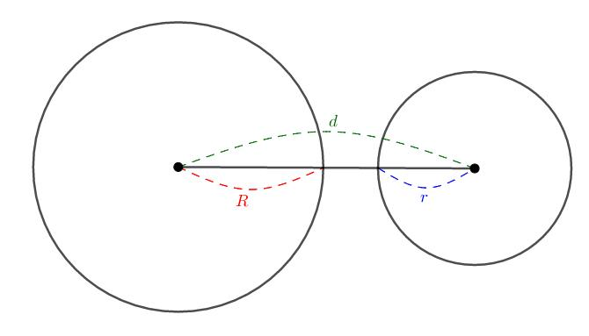
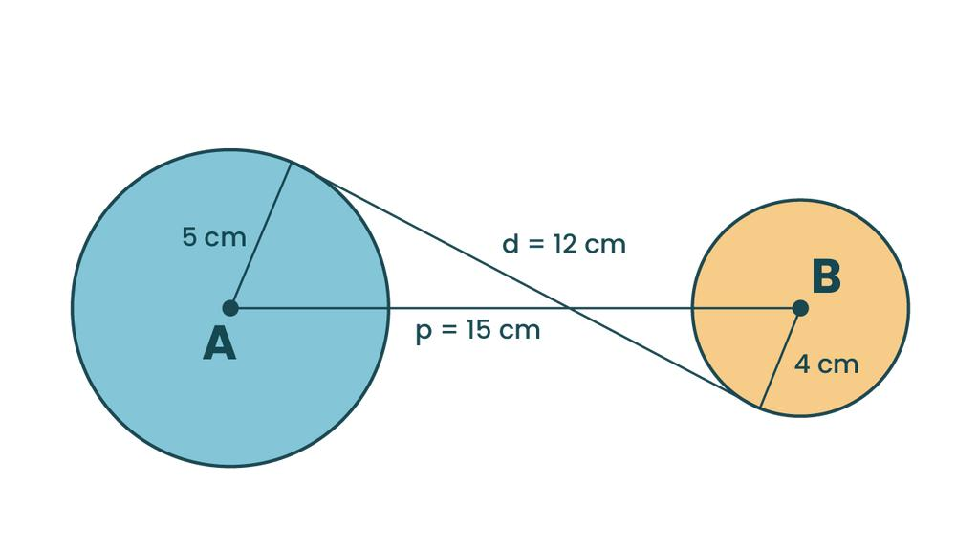
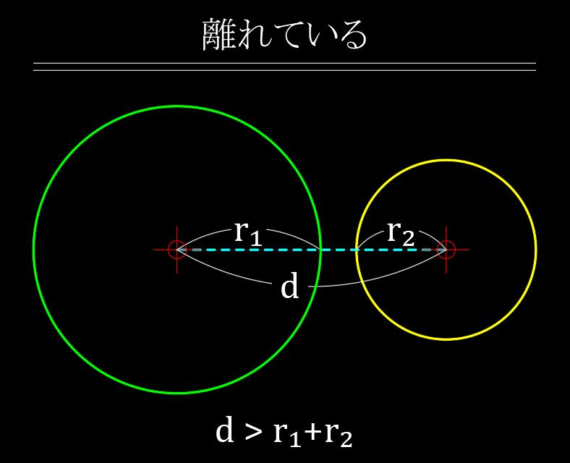

General Relationship
# Source: AI Source: Provided by: [Data Path: Persons Table -> ID Column: 1, Name_En Column: Motasem Essam] -> From: [ChatGPT] on [7/25/2026]
For two separated geometric regions:
$$\boxed{\text{Boundary Gap}=\text{Shortest Distance Between Their Boundaries}}$$
This makes Boundary Gap closely related to minimum distance and clearance.

Boundary Gap Subtypes
# Source: AI Source: Provided by: [Data Path: Persons Table -> ID Column: 1, Name_En Column: Motasem Essam] -> From: [ChatGPT] on [7/25/2026]
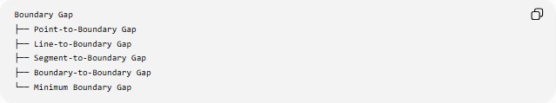
Boundary Gap
├── Point-to-Boundary Gap
├── Line-to-Boundary Gap
├── Segment-to-Boundary Gap
├── Boundary-to-Boundary Gap
└── Minimum Boundary Gap

Real-World Applications
# Source: AI Source: Provided by: [Data Path: Persons Table -> ID Column: 1, Name_En Column: Motasem Essam] -> From: [ChatGPT] on [7/25/2026]
Boundary gaps are important in:
- Architecture: spacing between walls and structures.
- Engineering: clearance between machine components.
- Construction: separation between structural boundaries.
- CAD: minimum clearance between designed objects.
- Manufacturing: required spacing between parts.
- Geographic information systems: separation between geographic boundaries.
- Computer graphics: collision and object-clearance calculations.

Key Points
# Source: AI Source: Provided by: [Data Path: Persons Table -> ID Column: 1, Name_En Column: Motasem Essam] -> From: [ChatGPT] on [7/25/2026]
- A Boundary Gap is the space separating two boundaries.
- It is usually measured using the shortest distance between the boundaries.
- For separated boundaries:
$$\boxed{g>0}$$
- For touching boundaries:
$$\boxed{g=0}$$
- It can apply to straight, curved, or irregular boundaries.
- It is closely related to minimum distance and clearance.

Conclusion
# Source: AI Source: Provided by: [Data Path: Persons Table -> ID Column: 1, Name_En Column: Motasem Essam] -> From: [ChatGPT] on [7/25/2026]
A Boundary Gap represents the separation between the boundaries of two geometric objects or regions. Unlike a Linear Gap, the boundaries can have arbitrary shapes, and the gap is generally defined by the minimum distance between the two boundaries.

